**WBS DIAGRAM**

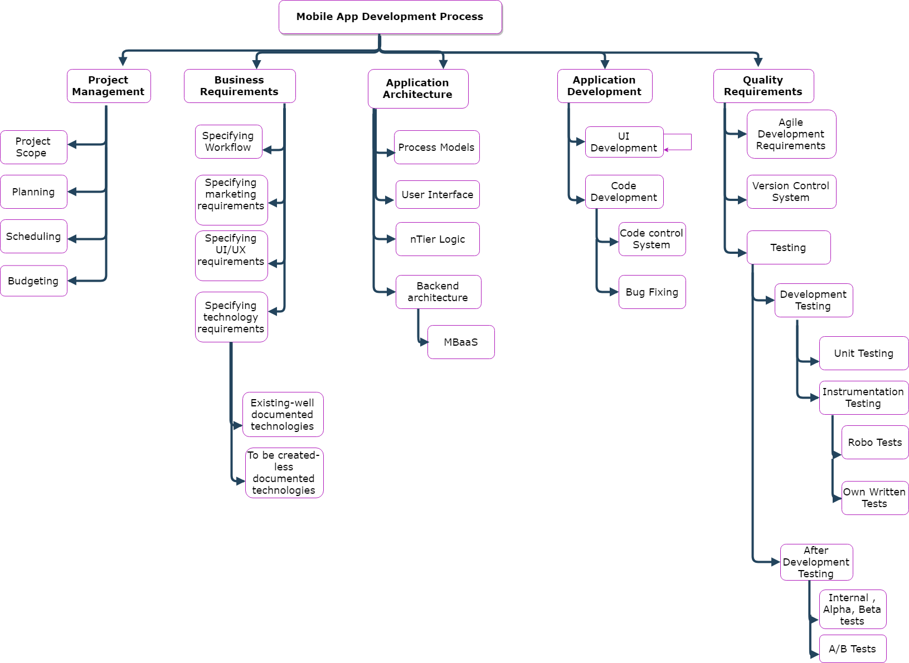

**WBS- DICTIONARY**

**nTierLogic:** Researching, choosing and implementing the process architecture for the application will be carried out. Between 2 tier and 3 tier architecture models, the most suitable one ought to be choosen according to the specific needs (easy implementation, costs etc..)

**Bug Fixing:** During the development process bugs will necessarily be fixed to continue the development activities. In addition to that, potential future bugs will also be researched for more robust codes.

**Version Control System:** During all phases of the development, GitHub/Bitbucket will be used for source code management, source control and revision controls for a better/easily managable program.

**Instumentation Testing:** For user-UI interactions and business logic implementation checkings, instrumentation testings are used. In addition to the own implementation testing codes, some automatic instrumentation testing tools(such as RoboTest) will also be utilized.

**A/B Tests:** To increase the user numbers& create better user experiences, different versions of the app with slight modifications will be put to the test as test and control groups. 3rd party tools and frameworks such as Optimizely and Firebase will be used for better fullfilment.

**Date of approval: Prepared by: Approved by:**

10.11.2018 M.K. Arslan M.K. Arslan